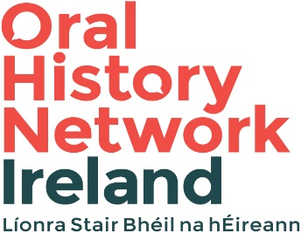

Name:

Address:

Email:

Institutional / Community Group Affiliation (if any):

Briefly outline why you feel that you should receive one of these fee waiver places (350 words max). Your response should include details of your interest or work in oral history to date. Priority will be given to applicants without alternative funding sources so please include a note regarding funding available to you.

Applications must be submitted to info@oralhistorynetworkireland.ie

